Direct Invoicing – 15.0 – Any Database – Program NVEDIT – Invoice Edit & Delete
- AR Global Parameters – DS20 Screen
DI File Audit Parameters – Invoice Header is “B” or “Y”
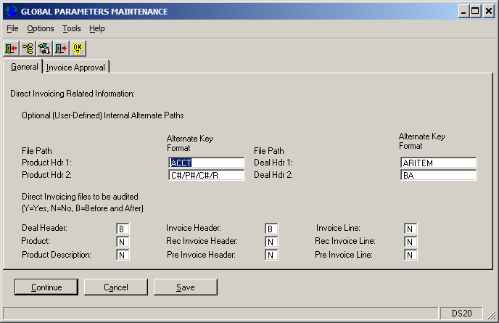
- Go to DI Invoice Entry and enter an Invoice.
In this case Coy is 001 – Customer is DANOFOR01 – Invoice Num is 138
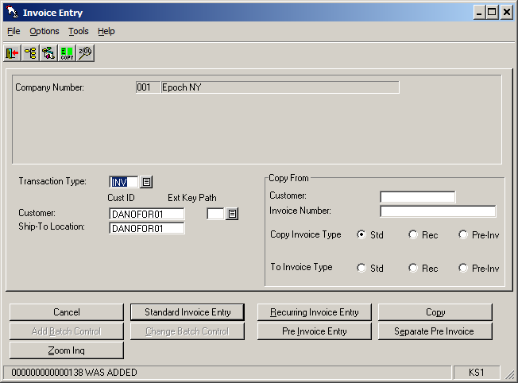

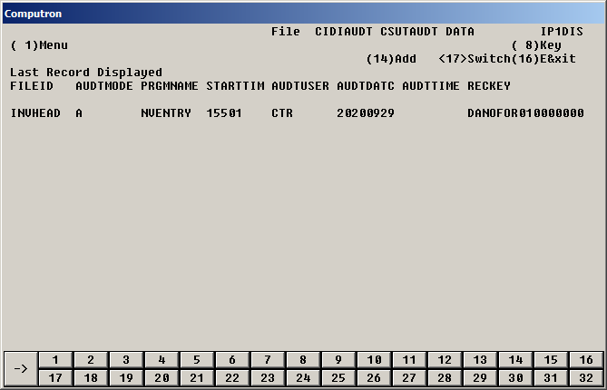

- Now use program NVEDIT – Di Invoice Edit and Delete to change the same invoice.
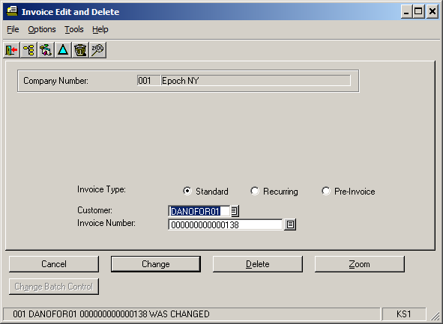

- Use CSDISPLY again to look at DI Audit file.
We should see that there are records with Audit Mode = “B” (Before) and “C” (Change).
However, neither of these records are here. See below.

- Set AR Global Parameters DS20 as follows:
Rec Invoice Header = “B” (or “Y”)
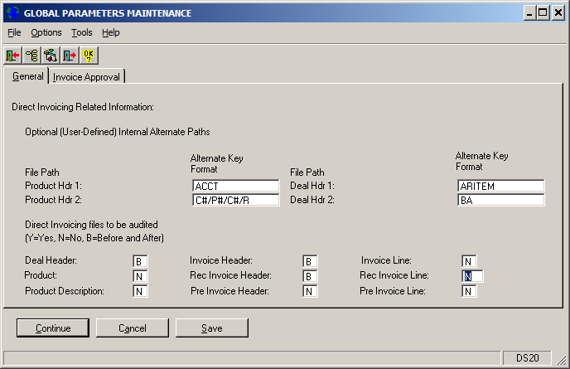

- Now use program NVEDIT – Di Invoice Edit and Delete to again change the same invoice.
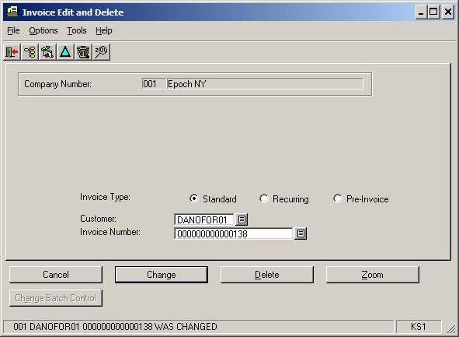

- Use CSDISPLY again to look at DI Audit file.
We should see that there are records with Audit Mode = “B” (Before) and “C” (Change).
As well as the original “A” (Add) record.
We now correctly see these records.
