**Surveyor Trouble-Shooting Guide**

**Purpose:**

The idea of this ‘guide’ is to provide a quick reference to assist someone in minimizing the impact on a customer yet extract all of the relevant information we need in order to correctly diagnose the issue.

**SURVEYOR BACKGROUND INFO:**

Surveyor runs as a Windows service for most of its work, but Windows services do not have the rights to run processes such as PSTM scripts in the users security context (this has been the case since Vista was released).  So Surveyor employs a small helper process called the Surveyor Agent User Module that runs in the users security context every time a user logs in.

The Surveyor Agent Service Module typically logs its actions to C:\Program Files (x86)\Verdiem\Surveyor Agent\Logs

Each Surveyor Agent User Module logs to a location within the Users folder.  My username is FredT, so my logs files are at C:\Users\FredT\AppData\Local\Verdiem Corporation\Surveyor Agent\Logs.  As you may know, the folder C:\Users\<username>\AppData is usually a hidden folder within Explorer- to see it you need to make a setting as described in <http://windows.microsoft.com/en-us/windows/show-hidden-files#show-hidden-files=windows-7>

**SURVEYOR ADMIN CONSOLE OVERVIEW:**

Your usage of the Surveyor Admin console will typically be limited to the following areas:

* Computer search, found on most screens:

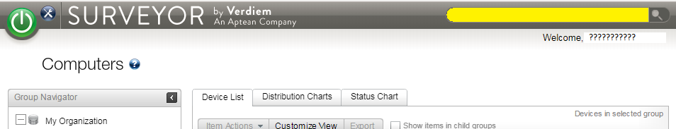

* 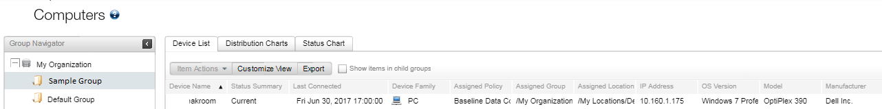Computer information, found as a result of a search
* Policy information, found under the green button ->Policies

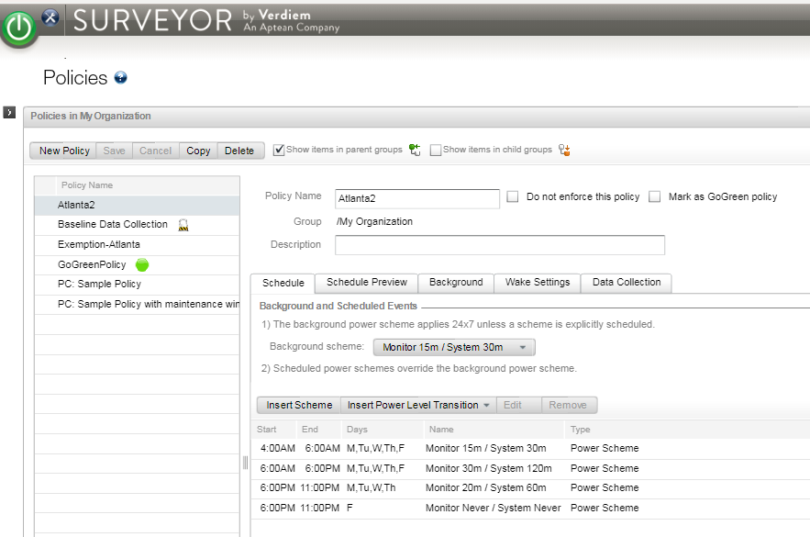

* Device Events, found under the green button ->Device Events

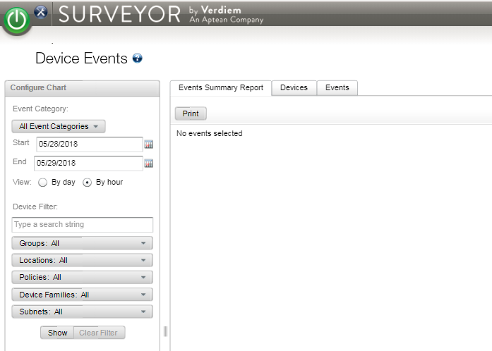

* Wake-On-LAN results, found under green button->Analytics->Operations Reports

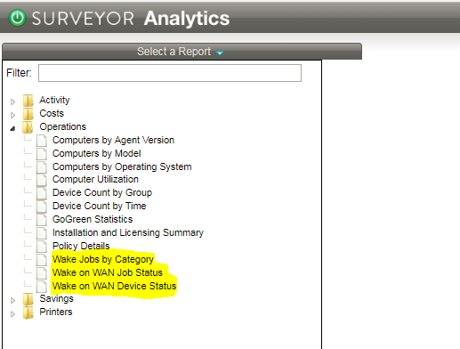

**TROUBLESHOOTING STEPS - HELPDESK**

1. Determine if the computer has Surveyor on it.
   1. Open Surveyor Admin console, click in upper right corner and put in computer name – it should be found.
2. Determine what the issue is:
   1. Computer failing - Provide Verdiem Customer Support Technician with:
      1. Surveyor Agent Logs (C:\Program Files (x86)\Verdiem\Surveyor Agent\Logs)
      2. Client Event logs
      3. Date/time and description of fault/failure
   2. Power Policy not followed
      1. Date/time and description of failure to follow policy
      2. Confirmation of policy client is running
         1. Surveyor Admin console, find computer, show ‘Policy’ column
         2. Surveyor Admin console, green button, Policies, screenshot of selected policy
      3. Surveyor Agent logs (C:\Program Files (x86)\Verdiem\Surveyor Agent\Logs)
   3. Power Policy not liked
      1. Date/time and description of how policy adversely affects user
   4. Other
      1. Date/time and description of issue
      2. Revert policy if required/appropriate
      3. Contact Verdiem Customer Support Technician as needed

In general, you can disable the Surveyor policy from a computer as a quick/simple ‘fix’, allowing the user to get back to work and for you to provide the Verdiem Customer Support Technician with details to help solve the problem at a later time. To do this, open up the Surveyor Admin console, find the suspect device in the Computers listing under the green button, right-click on the computer and choose ‘Manually assign policy’. Next, choose the ‘Baseline Data Collection’ policy – which will revert the machine to pre-Surveyor behavior. Finally, follow the instructions provided previously to gather the appropriate information needed so that your Verdiem Customer Support Technician can resolve the issue.

**WHAT ARE THE TYPICAL ISSUES PRESENTED BY END-USERS?**

* *Computer behavior changes*
  + As a result of implementing power management policies, computers will typically behave differently as compared to how they operated prior to using Surveyor. The biggest change that users notice are that the computer/displays are off (the computer and displays are actually asleep) when the user sees their computer for the first time in the morning. This is because Surveyor will typically have put the machine to sleep overnight.
  + The best way to alleviate this issue is to notify users ahead of the changes. Verdiem suppies an end-user notification toolkit that provides 5 suggested templates for this.
* *Mouse and/or keyboard don’t wake the computer once it goes to sleep*
  + If these are wired devices, this is typically a result of the USB port(s) that they are connected to going to sleep – so it isn’t registering the mouse/keyboard activity – making these devices ‘dead’ to the world.
    1. Surveyor provides two solutions for this – one is a direct policy setting to configure known usb devices; and the second is a script that can be applied to configure the USB Root Hubs to disable their power management (which is what is driving them to sleep).
  + If these devices are wireless, the odds are good that the wireless devices are ‘sleeping’ to conserve their battery power. In those cases, wiggling the mouse will not work, but clicking a key on the keyboard and/or clicking a mouse button will wake up those devices and then wake up the computer.
* *The computer does not wake from sleep using Wake-On-Lan (WOL) from the Surveyor interface.*
  + WOL need four things configured properly for it to work:
    1. Surveyor configured to enable WOL
       - Work with Verdiem Customer Support Technician for this, this is a simple, 5-minute exercise.
    2. The NIC’s for the computers must be configured to allow/accept WOL packets
       - Surveyor policies and options should make this fairly easy for known NICs
    3. The BIOS’ must allow for WOL. The manufacturer typically configures this properly.
    4. In Windows 8 and newer OS’s, Fast Startup/Hibernate needs to be disabled.
       - See Verdiem Customer Support Technician for assistance
    5. In certain cases your Verdiem Customer Support Technician will request Wake-On-LAN success/operations reports. These can be found as described above.
* *User complains that their machine is shutting off while they are working*
  + First, confirm that this is true. For example, could the display be blanking out only?
    1. To do so, the Admin console can be used to verify that the machine is powering down. The steps to confirm:
       - Open Surveyor Admin console
       - Under the green button, select ‘Device Events’
       - Next input the correct time period in question and the machine name
       - Review the ‘Events’ tab on the right side during the time in question, looking for indication of System Sleep or Shutdown.
    2. In general, the user will have the display blank out for some reason (like they were away at a meeting) and when they return the blank screen is a new behavior – causing them to believe the machine has shut down.
  + If the investigation using Device Events confirms that the machine has powered down, determine the following:
    1. What policy is supposed to be in force for that machine at that time?
    2. Was the policy in force? (This can be determined by finding the machine in the Admin console/Computers view and looking at the ‘Policy’ column.
    3. What was the policy settings that should have been in force at that time? Should the machine have powered down per the policy settings?
       - * If so, the policy may need to be changed
         * If not, then collect the Surveyor Client log files (located typically at c:/program files (x86)/Verdiem/Surveyor Agent/Logs) and server log files (typically on server at c:/program files (x86)/Verdiem/Surveyor/logs) and send to Verdiem Customer Support Technician along with the details (time of problem, name of machine, etc…)
    4. Did the Device Events indicate an unexpected power down – in other words, an error situation?
       - If so, contact your Verdiem Customer Support Technician immediately.
* *User complains that their monitor is going to sleep too quickly (or their computer is going to sleep in the evening too soon).*
  + This sounds like a policy issue (policy not fitting the user well). Gather the appropriate information (as suggested earlier) and provide to the Verdiem Customer Support Technician. Then revert the end-user policy until a change can be effected.

End-User Details:

Username: _____________________________________________________________________

Machine Name: _________________________________________________________________

Machine IP Address: _____________________________________________________________

Date/Time issue reported: ________________________________________________________

Description or issue: _____________________________________________________________

______________________________________________________________________________

______________________________________________________________________________

______________________________________________________________________________

______________________________________________________________________________

______________________________________________________________________________

Are Surveyor Agent Log files being supplied? _________________________________________

Are client event logs being supplied? _______________________________________________

Are Surveyor Server log files being supplied? _________________________________________