1. Go to the deployment server (remote desktop).
2. Navigate to the Software\Bin folder in the Chameleon installation.
3. Run the Config. tool.  It may work better of you run this as an Administrator – (right click on it and choose run as “administrator”).

The password is “admin”.

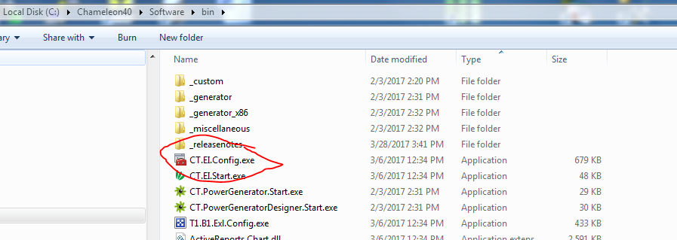

1. Select the Configuration Name on the left and select “Publish Software” on the toolbar.

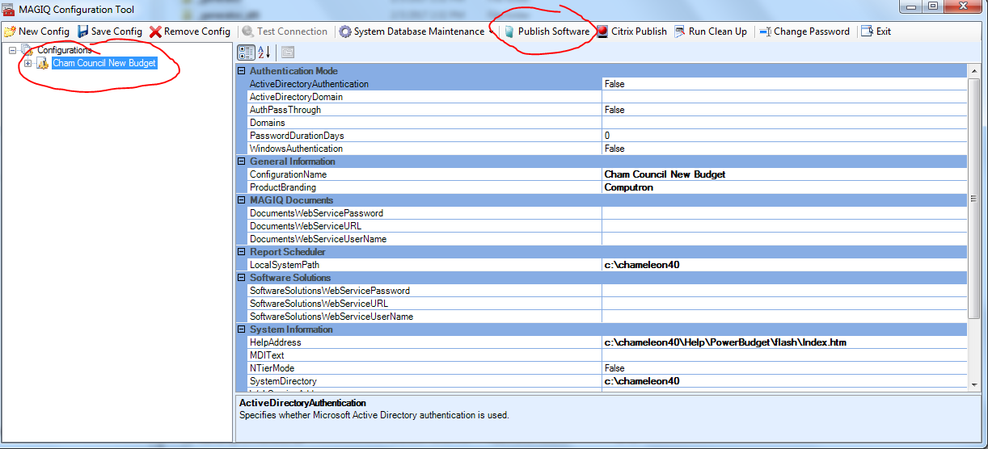

1. A dialog window will open showing the published revision number:

This will increment automatically (see the checkbox).

We generally use the Major/Minor fields to represent the actual version number. But it’s important that this number never is decreased. So whatever it was before it should only be changed to higher values.

Unless you are installing a new release of the software you should just let the program increment the revision.

Click “Publish”.

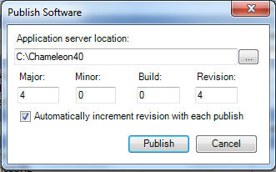

1. A process window will open showing various scripted operations. It will close on its own.
2. You can close the config tool and test the deployment shortcut from your PC.