Everest Installation - Quick Guide

Overview
This document provides a quick overview of Everest Server and Client Installation in the server

Prerequisites
- Windows Server 2016 is installed
- SQL Server 2016 SP1
- SQL Server Management Studio

Configuration Prerequisites
- SQL Server Server is configured to mixed authentication
- sa user password should be available
- SMTP configuration for initial login, can use smtp4dev as replacement

Installation Steps
The Installation is quite straightforward, the installation itself will not take a long amount of time, although there’s some preliminary steps that need to be taken.

Preparation
Since there’s some changes in the Windows and SQL Server feature we may need to adjust the configuration to allow the Everest to be installed properly.

Enabling COM+ for Windows
We modify the registry to allow COM+ to have Remote Access,
- Run RegEdit.exe from start
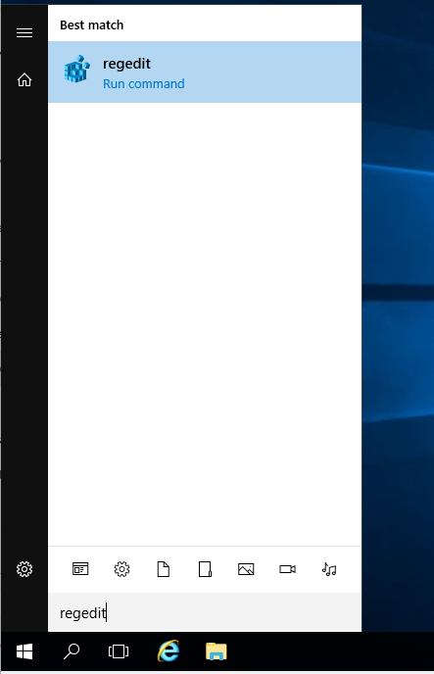
- Change the value of RemoteAccessEnabled from 0 to 1 under the key [HKEY_LOCAL_MACHINE\SOFTWARE\Microsoft\COM3
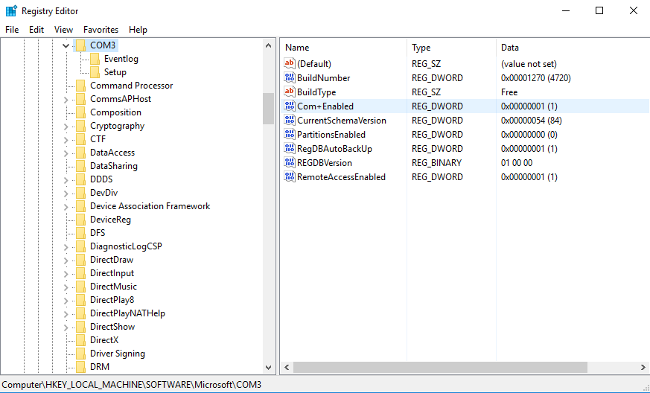
- Restart the server
Reference
- 0x80004027 error when you try to remotely access COM+ object after you upgrade to Windows Server 2016

Enable CLR in the SQL Server 2016
- Open SQL Server Management Studio
- Open new query
- Run these command
EXEC sp_configure 'clr enabled', 1;
RECONFIGURE;
GO
- Click Run
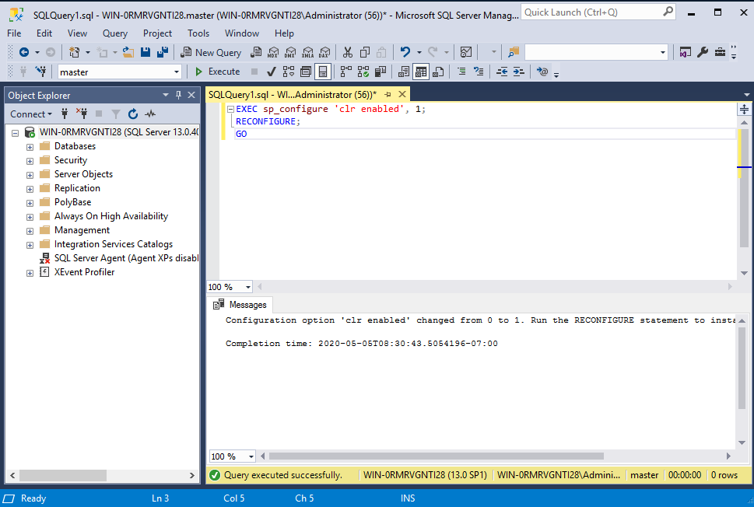

Installation
Run the Install application from the extracted Everest Installation directory
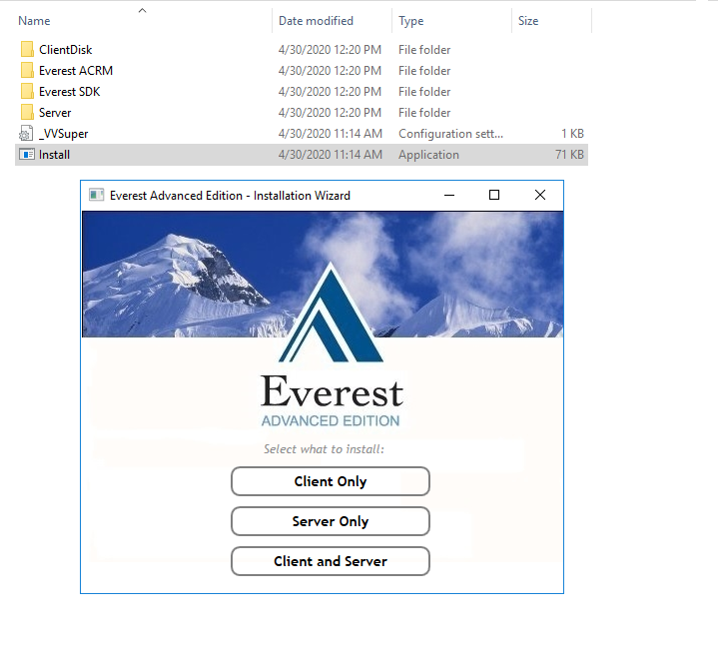
And select Client and server, this will execute two installation in sequence

Server-Side Installation
- Follow the wizard, accept the EULA and click Next
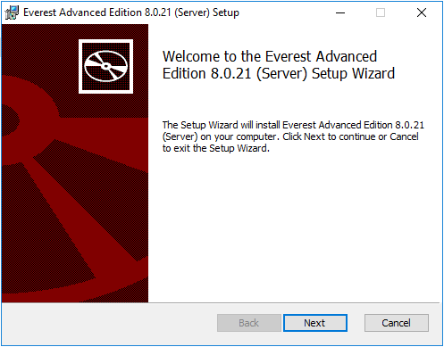
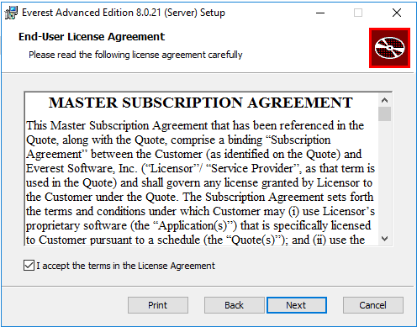
- Select the installation destination, please consider a location with large space as the database file will be defaulted to the given destination
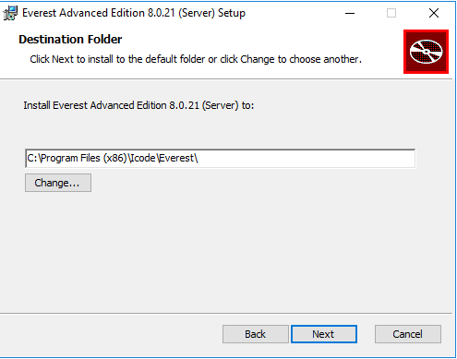
- Select the installation Option, this will be defaulted to Typical that would install Application Server, Data Server and It’s Sample Data, and Report Server
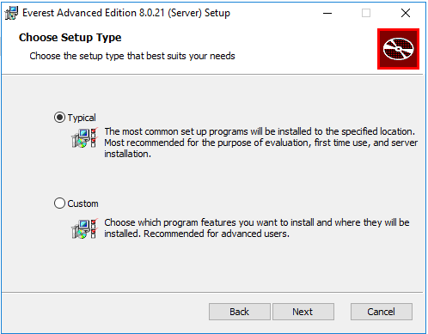
- Specify the User that will be used to run the Everest’s application server
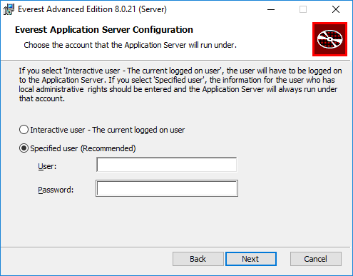
- Enter SQL Server’s sa password to configure the server side installation and database connectivity.
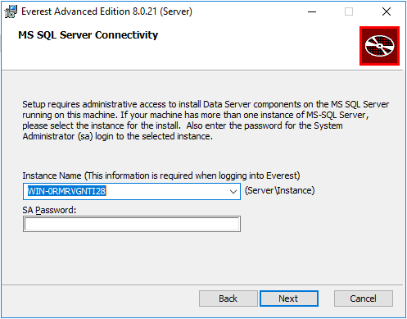
- Summary of the Installed components
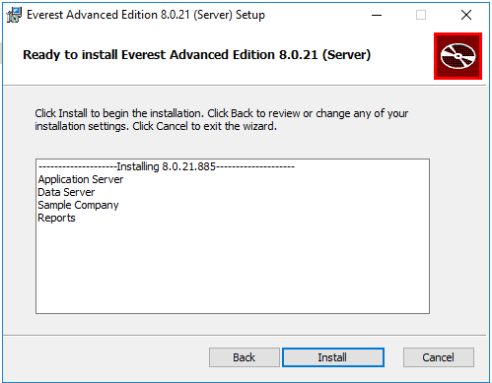
Click Install to continue the installation
- Server Component Installation completed
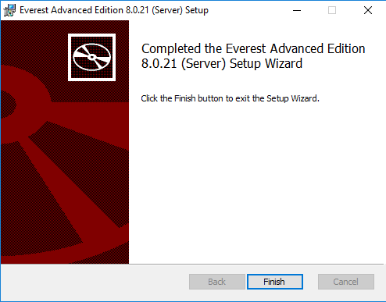

Client-Side Installation
- Follow the wizard, accept the EULA and click Next
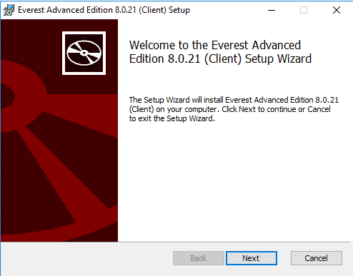
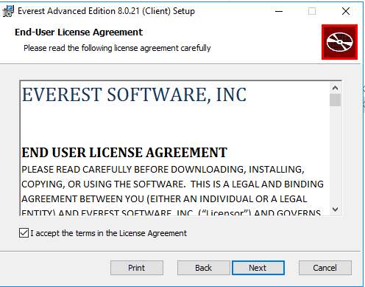
- Choose Setup type to select which component are being installed.
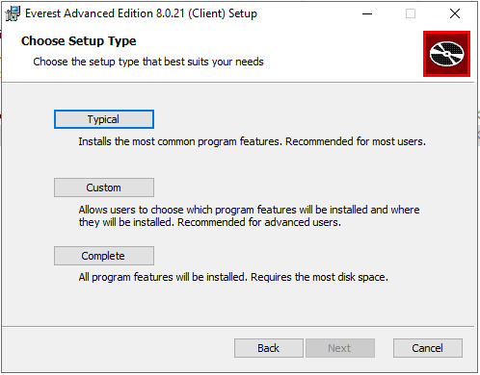
- Finalization before executing the Installation, should there be additional component needs to be installed locally click Back, or proceed with the installation.
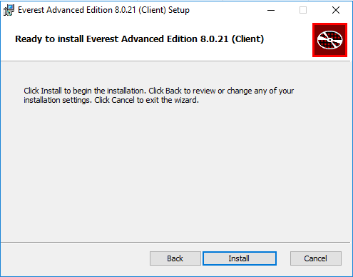
- Client-Side Installation completed
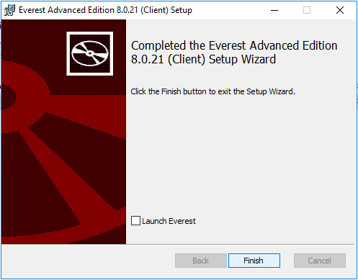

Verification
The verification steps that needs to be done is to login with default super user for the sample company to verify that the sample company is operational.
- Open Everest Client
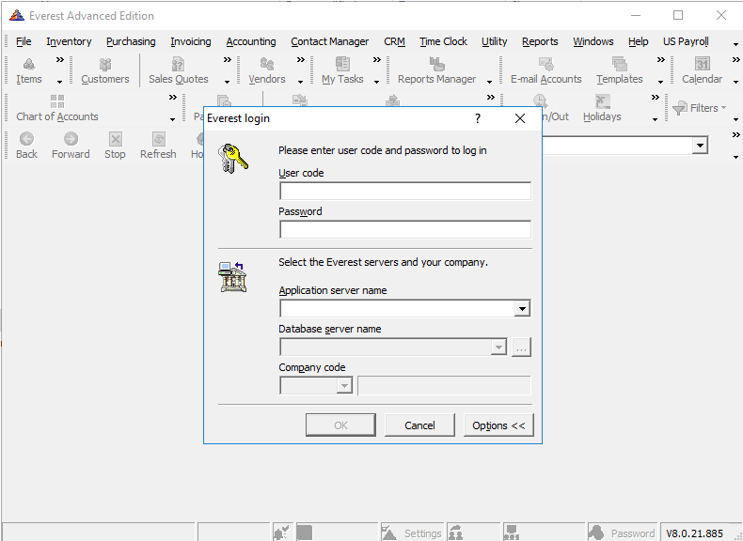
- Login with credential
  - User Code : sup
  - Password : super
  - Application Server Name : server address where the application is installed
  - Database Server Name : Server where database is installed
  - Company Code : ASC (ACCELL SAMPLE COMPANY)
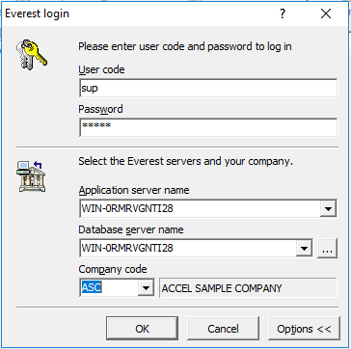
Click OK
- This will trigger a change for SUP user. Populate the requested field, in the case if the smtp server is not available, other methods, such as temporary SMTP server can be used.
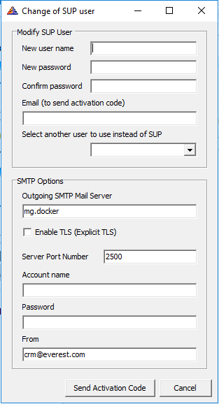
Once populated, click Send Activation code to receive the activation code in the mail.
- In the received email there should be an activation that needs to be entered in the activation window.
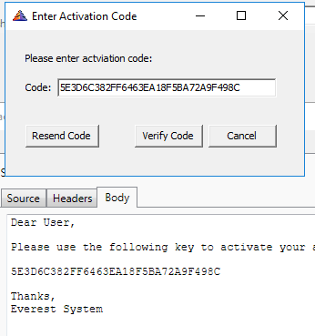
And click Verify Code to verify the code being sent.
- This will disable the default SUP user and activate the new user created in the previous steps
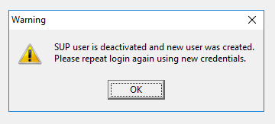
- Login again with the created user by restarting Everest or Open the company, File | Open Company
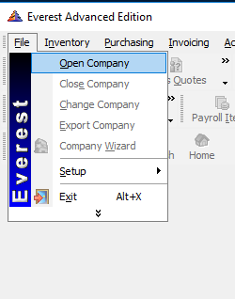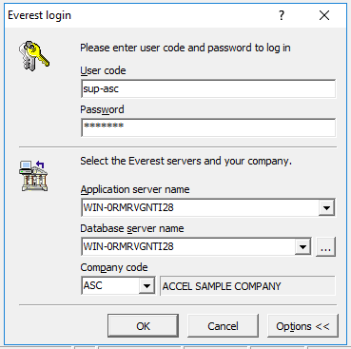
Click OK to login
- Select the Default Jurisdiction and Location/Sub-Location
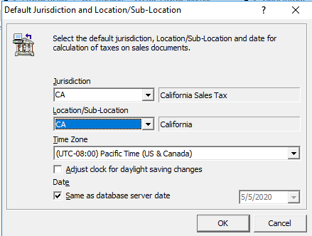
Click OK to complete the Login process.
- If there’s no problem, The Everest main screen will be presented Normally.
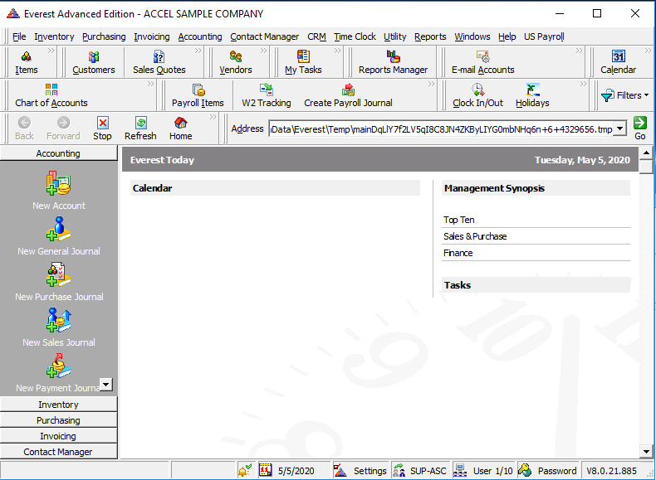
- This conclude the installation verification

Notes
- In the case for any problem on configuration, please refer to the Everest Whitepaper settings article
- And as a reminder, we suggest to install the everest in the fresh environment and test the feature in a separate test environment to confirm the feature and function
- Please refer to Manage Upgrade Service should there be a need for upgrading the Everest version as this are not part of the scope of this document due to multiple aspect of the upgrade path for each feature configured.

